**DATAGUARD OUT OF SYNC**

**10.102.117.11/12 - Primary Database/DC1**

**10.102.217.11/12 – Standby Database/DC2**

-------------------------------------------------------------------

1. Connect to the Primary database/DC1 (10.102.117.11):-

* [oracle@cdc1aodbdb1 ~]$ ps -ef|grep pmon

Export the oracle sid using below command

* export ORACLE_SID=AMSPRD1

connect the SQL prompt and check the status of database.

* sqlplus / as sysdba
* select name, open_mode, database_role from v$database;

2. Now, Connect to the Standby database(DC2)/ 10.102.217.11:-

* [oracle@cdc1aodbdb1 ~]$ ps -ef|grep pmon

Export oracle_sid to connect the instance.

* export ORACLE_SID=AMSPRDSTBY1

Now, connect and check the status of database on standby (DC2).

* sqlplus / as sysdba
* select name, open_mode, database_role from v$database;

Here, We can able to check the Log gap between DC1 and DC2 using below command on DC2.

Command: -

SELECT ARCH.THREAD# "Thread", ARCH.SEQUENCE# "Last Sequence Received", APPL.SEQUENCE# "Last Sequence Applied", (ARCH.SEQUENCE# - APPL.SEQUENCE#) "Difference"

FROM

(SELECT THREAD# ,SEQUENCE# FROM V$ARCHIVED_LOG WHERE (THREAD#,FIRST_TIME ) IN (SELECT THREAD#,MAX(FIRST_TIME) FROM V$ARCHIVED_LOG GROUP BY THREAD#)) ARCH,

(SELECT THREAD# ,SEQUENCE# FROM V$LOG_HISTORY WHERE (THREAD#,FIRST_TIME ) IN (SELECT THREAD#,MAX(FIRST_TIME) FROM V$LOG_HISTORY GROUP BY THREAD#)) APPL

WHERE

ARCH.THREAD# = APPL.THREAD#

ORDER BY 1;

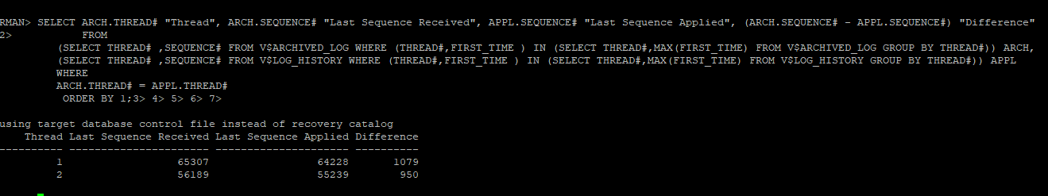

We observed there is a huge log gap between DC1 and DC2. So, it is out of sync.

* In Thread 1, we observed that there is huge log gap i.e. “1079”
* In Thread 2 also we observed that huge log gap i.e. “950”

Now, our aim is to resolve this log gap and synchronize the DC1 and DC2 as per oracle method using “service name”.

As per “Service Name” method to resolve this problem: -

Connect node 1 on DC1 as per below steps:

* [oracle@cdc1aodbdb1 ~]$ ps -ef|grep pmon
* export ORACLE_SID=AMSPRD1
* sqlplus / as sysdba
* select name, open_mode, database_role from v$database;

We have already discussed this connecting process with the above steps.

Similarly, we are connecting to instance 2 on DC1 i.e. 10.102.117.12

* [oracle@cdc1aodbdb2 ~]$ ps -ef|grep pmon
* export ORACLE_SID=AMSPRD2
* sqlplus / as sysdba
* select instance_name, open_mode, database_role from v$database, v$instance;

Now, we connected node 2 on DC1:

Here, we must do “DEFER” the log_archive_dest_state_2 parameter on both the nodes on DC1.

Command:-

On node 1/10.102.117.11:

----------------------------------

* alter system set log_archive_dest_state_2=DEFER scope=both sid='*';

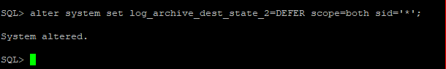

On node 2/10.102.117.12:

--------------------------------------

Connect node 2 and “DEFER” the log_archive_dest_state_2 parameter on DC1.

* alter system set log_archive_dest_state_2=DEFER scope=both sid='*';



**On Standby Database: -**

Now connect to the standby database/DC2 node 1 and node 2 (10.102.217.11/12):

**Node_01/10.102.217.12: -**

Export oracle sid to connect the node_2

* [oracle@cdc2aodbdb1 ~]$ ps -ef|grep pmon
* export ORACLE_SID= AMSPRDSTBY2
* sqlplus / as sysdba
* select instance_name, open_mode, database_role from v$database, v$instance;

After connection of standby/DC1 database, do follow the below steps.

* Down the database on both nodes (node1 and Node 2)
* Start the database with nomount state on only one node, either node 1 or node 2.

Note: Before down the database “Disable“ MRP on standby/DC2

Down the MRP on standby database using below command:

* alter database recover managed standby database cancel;

After dawn the MRP weather check it’s status up or not.

* Set lines 200 pages 200

col block# for 9999999

select PROCESS, status, client_process, SEQUENCE#, block# from v$managed_standby;

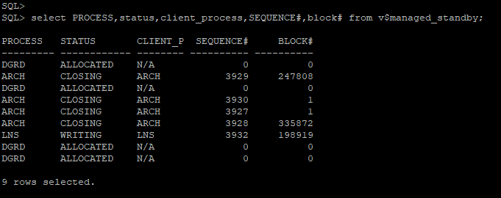

Now, here MRP is showing down state.

Down the database on node_02:

* shut immediate;

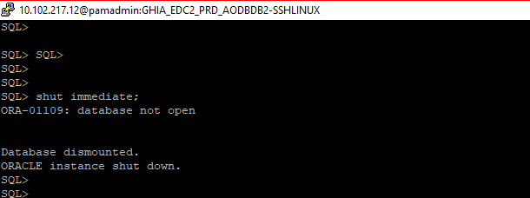

**NODE_1/10.102.217.11:-**

**---------------------------------**

Now, connect node_01 on DC2 / 10.102.217.11:-

Export oracle sid to connect the node_1

* [oracle@cdc2aodbdb1 ~]$ ps -ef|grep pmon
* export ORACLE_SID= AMSPRDSTBY1
* sqlplus / as sysdba
* select instance_name, open_mode, database_role from v$database, v$instance;

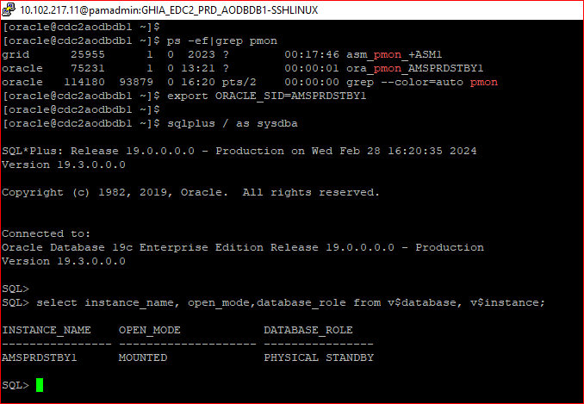

Down the database node_1

* shut immediate;

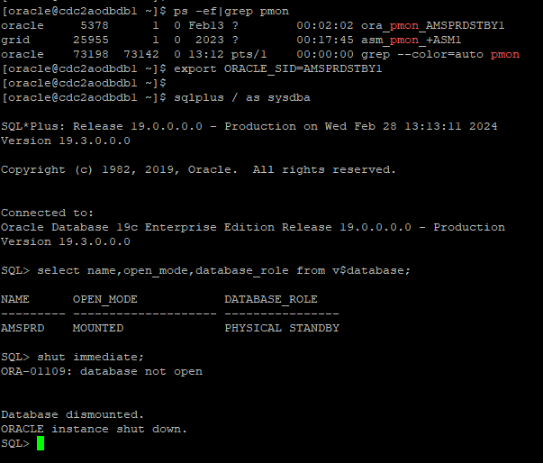

Both the nodes are down state, now we can up the database with nomount state only one node 1.

Connect rman and up the database with nomount state.

* rman target /
* startup nomount.

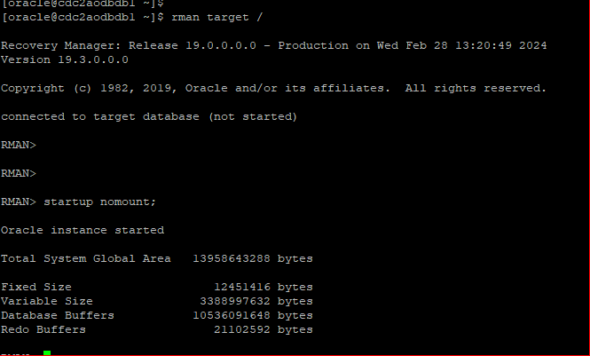

Restore standby control file from using primary database service name as show in below steps.

* restore standby controlfile from service “AMSPRD”

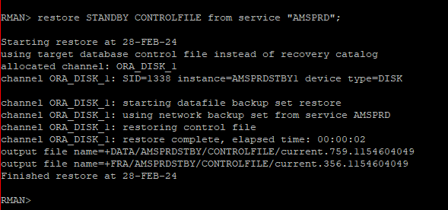

Here, standby control file was restored by using primary db service name.

Similarly, we will do recovery process using the same as primary service name.

* alter database mount;
* recover standby database from service AMSPRD;

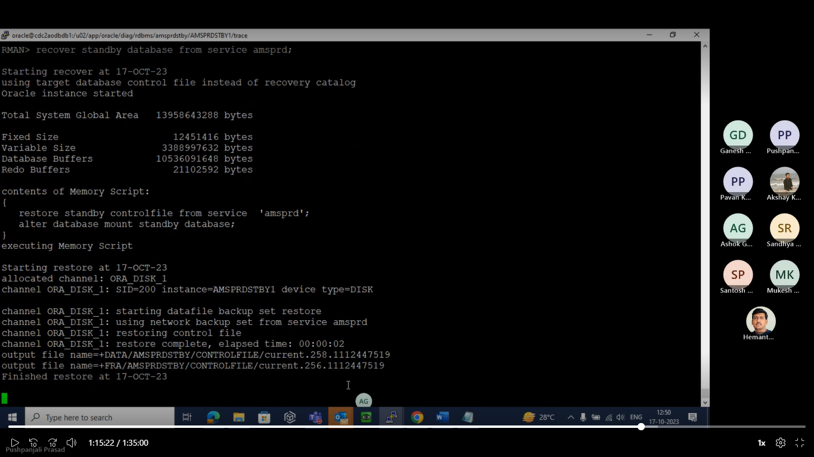

After completion of recover process follow the below steps.

* Enable the MRP on standby side.
* Up the node 2 on standby database/DC2.
* On primary database, enable log_archive_dest_state_2 parameter on both nodes.

Enabling MRP on node 1;-

* alter database recover managed standby database disconnect from session;

Here, check once MRP status.

col block# for 9999999

select PROCESS, status, client_process, SEQUENCE#, block# from v$managed_standby;

On standby, Up the node 2:

To up the node follow below steps.

* export ORACLE_SID= AMSPRDSTBY2
* sqlplus / as sysdba
* startup mount;

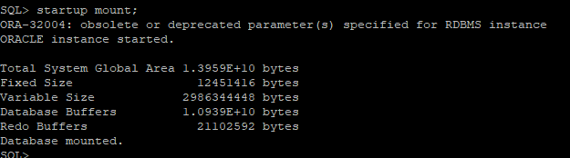

Now, check the status of node:

Select instance_name, status, database_role from v$database, v$instance;

On standby side both nodes and MRP also up and running.

We have to check log gap between DC1 and DC2:

* SELECT ARCH.THREAD# "Thread", ARCH.SEQUENCE# "Last Sequence Received", APPL.SEQUENCE# "Last Sequence Applied", (ARCH.SEQUENCE# - APPL.SEQUENCE#) "Difference"

FROM

(SELECT THREAD# ,SEQUENCE# FROM V$ARCHIVED_LOG WHERE (THREAD#,FIRST_TIME ) IN (SELECT THREAD#,MAX(FIRST_TIME) FROM V$ARCHIVED_LOG GROUP BY THREAD#)) ARCH,

(SELECT THREAD# ,SEQUENCE# FROM V$LOG_HISTORY WHERE (THREAD#,FIRST_TIME ) IN (SELECT THREAD#,MAX(FIRST_TIME) FROM V$LOG_HISTORY GROUP BY THREAD#)) APPL

WHERE

ARCH.THREAD# = APPL.THREAD#

ORDER BY 1;

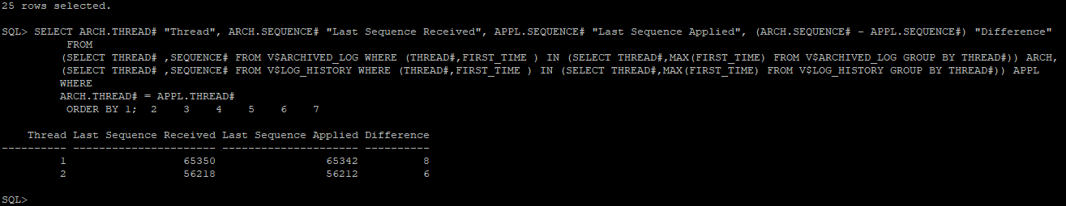

So, finally we have resolved the huge log gap between DC1 and DC2. The logs will be shipping.